Project Scope

“A step By Step Guide to Building a Personal Computer”

Project name: A Step by Step Guide to Building your own PC”
Project Supervisor: Aoife Fox
Project start date: 1/11/2011 Project end date: 15/12/2011
Project Budget: $1,000

Objective: The aim of this project is to create a step-by-step illustrated guide showing the user how to build a Personal Computer. The Purpose of this guide will be for information, education, referencing and enjoyment and of use to any person interested in building a Personal Computer or interested in researching the topic. The Initial Planning budget for this project is $1,000.
This guide will reflect how it is possible to build a Personal Computer with minimal problems and to a high standard, guiding the user as needed. All tasks will be completed by 14/12/2011 and the project will be ready for printing.

Proposed Activity list
Before Buying Parts
1. Prepare a list of required components
2. Price components
3. Ensure safety requirements and equipment available
4. Ensure camera available and in working order
5. Ensure documentation equipment available
In Store
6. Buy required components
7. Payment for components
8. Transport components to work area
In Work Area
9. Ensure safety standard adhered to and clean work area available
10. Set up work tools and work bench
11. Set up camera
12. Layout components
13. Double check all requirements
14. Start to Build PC
15. Install the motherboard
16. Install the Processor
17. Install the CPU cooler
18. Install the Ram
19. Install Expansion cards
20. Install Hard drive
21. Install Auxiliary drive
22. Install Panel connectors
23. Document all work
24. Finish Build
25. Photograph each stage
26. Clean work area
27. Send documentation and Photographs to Publisher

Gantt chart for Proposed Project Schedule

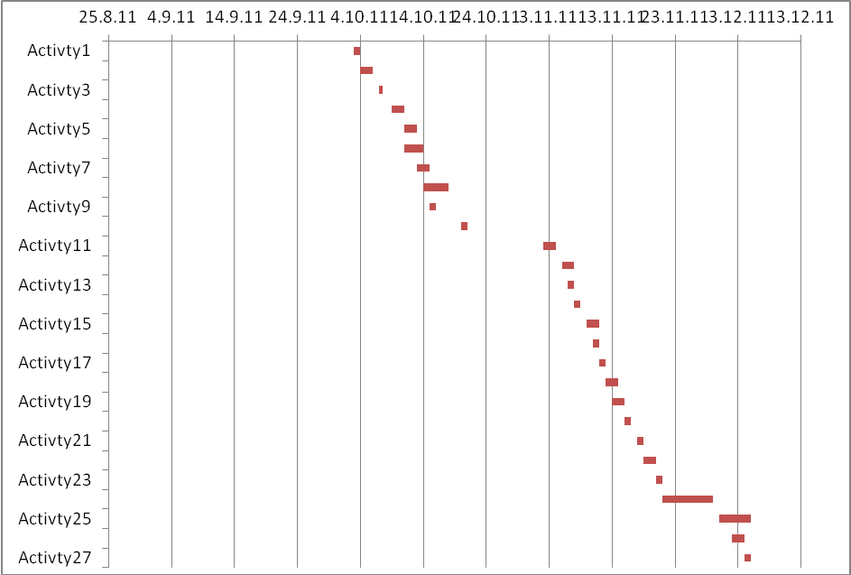

What are the defining features and benefits of this product?

The benefits of this product are that it will provide the user with the information needed to build their own personal system. Many people prefer a higher specification system and this guide will help them make the choice between buy or build. Currently there is a gap in the market in this area. It may occur that some components might not be available at specified time in this event the project may possibly be delayed. In the event of this problem some time can be gained in other areas of this project to compensate enabling delivery on schedule. I propose meeting on a weekly basis for continuous updates of progress.

